Mortality Rate

Age - Cause analysis

The purpose of this research is to understand the differences in mortality rate and descriptive analytic report about Mortality rates of Japan and Switzerland.

The dimensions are Causes, age group, year, gender, countries, and Death rates.

Investigating causes of death rate in different age groups for 10 year periods:

Processing:

For convention, the whole 60 years period, was divided into 6, ten-year periods.

In order two illustrate the line charts a dictionary was made which contained 6 data frames (one for each 10-year period). The death rate for each cause, gender, age group, and country, was calculated based on getting the average death rate of the whole 10-year period with consideration to the named factors.

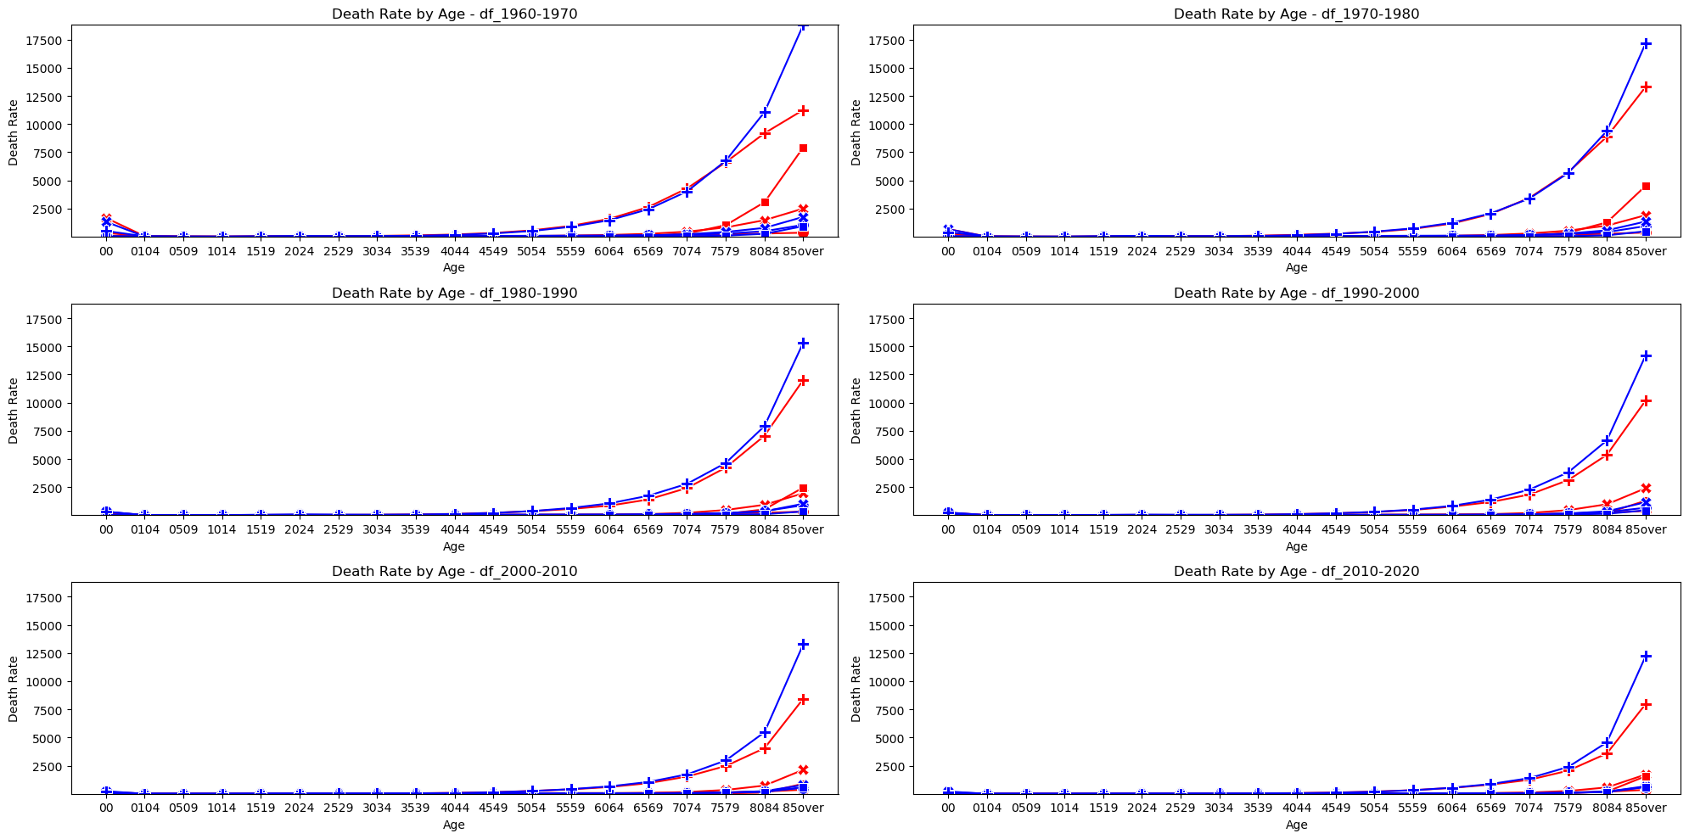

|  |  |
| --- | --- |
| Japan | red |
| Switzerland | blue |
| noncommunicable-diseases | + |
| communicable-maternal-perinatal-nutritional-conditions | x |
| defined-diseases | | | |
| injuries | O |

Investigating death rate for all years and for each age group:

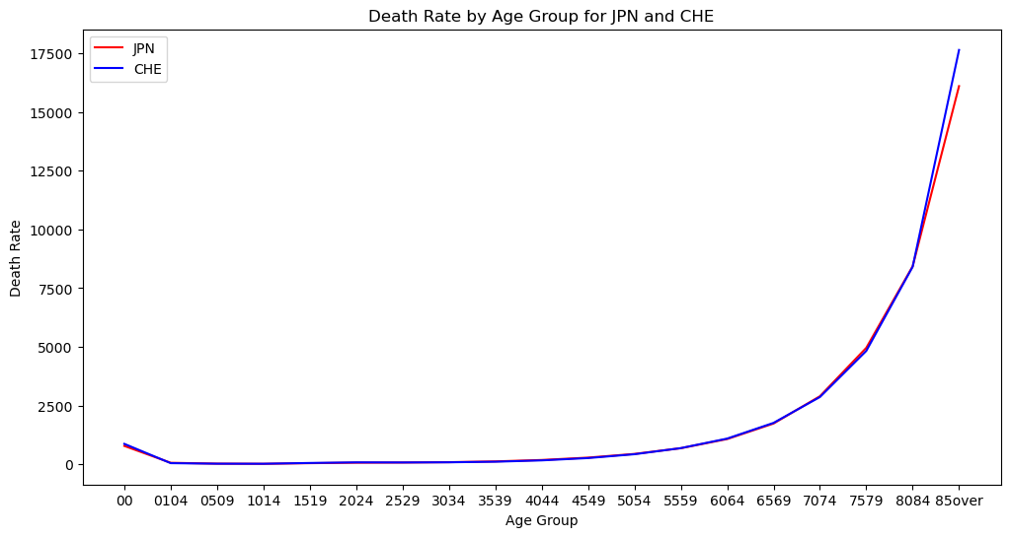The death rate for each age group was determined by getting the all-causes death rate of each year, summing them all together, and then dividing it by 60.

The Anderson exponential test was conducted for significance levels between 0.05 to 1 for both JPN and CHE and the results show that the data does not follow an exponential distribution.

Do this for all different causes

Investigating each cause for all age group in the whole 60-year period:

|  |  |  |  |
| --- | --- | --- | --- |
| **cause** | **JPN_death_rate** |  | **CHE_death_rate** |
| 1 | 54 | < | 65 |
| 2 | 86 | > | 46 |
| 3 | 43 | > | 21 |
| 4 | 576 | < | 751 |

|  |  |
| --- | --- |
| JPN | 4 > 2 > 1 > 3 |
| CHE | **4 > 1 > 2 > 3** |

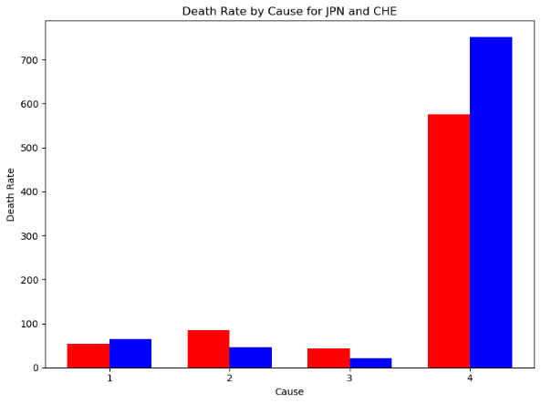

Questions:

1 – what are the main causes of death in each group and how is it different in each country?

2 – how significant or major are the most probable cause for each age group and for each country?

|  |  |
| --- | --- |
| 1 | Injuries |
| 2 | communicable-maternal-perinatal-nutritional-conditions |
| 3 | defined-diseases |
| 4 | noncommunicable-diseases |

Investigating each cause for each age group in the whole 60-year period:

The average death rate for each cause was done by getting the death rate for each year, sum all of them for the whole 60 years, and then dividing it by 60.

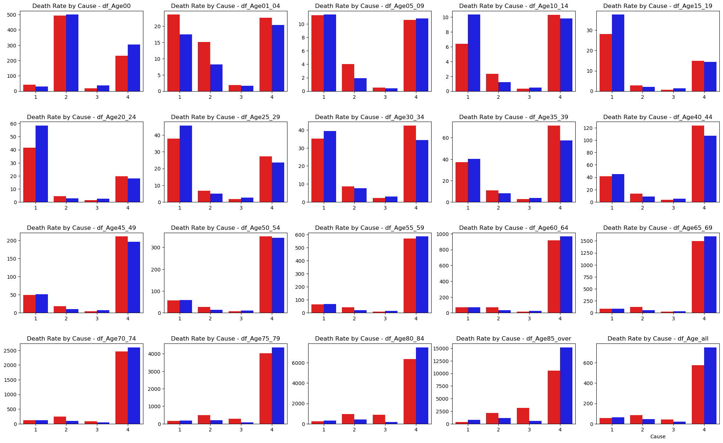

|  |  |  |  |  |  |
| --- | --- | --- | --- | --- | --- |
| **Age Group** | **JPN** | **CHE** | **highest-cause-JPN** | **highest-cause-CHE** | **Conclusion** |
| 0 | 2413 | 2431 | **63%** | **57%** | **Cause 2 is the most probable for newborns** |
| 1-4 | 1423 | 4123 | **37%** | **43%** | **In these age groups, for 1–4-year-olds in CHE the main cause of death was cause 4, and also for 10-15 year-olds in JPN, in other age groups it was always cause 1.** |
| 5-9 | 1423 | 1423 | **43%** | **46%** |
| 10-14 | 4123 | 1423 | **53%** | **47%** |
| 15-19 | 1423 | 1423 | **61%** | **68%** | **In these age groups, the probability of cause 1 is the highest for both countries.**  **Moreover, they have the same priority for causes of death.**  **In Ages between 25-29, the probability of cause 1 is not significant in comparison with others.** |
| 20-24 | 1423 | 1423 | **62%** | **72%** |
| 25-29 | 1423 | 1423 | **51%** | **59%** |
| 30-34 | 4123 | 4123 | **48%** | **47%** | **In these age groups, the probability of cause 4 is the highest for both countries.**  **For all the mentioned age groups, they have the same priority for causes of death.**  **In Ages between 30-39, the probability of cause 4 is not significant.** |
| 35-39 | 4123 | 4123 | **58%** | **53%** |
| 40-44 | 4123 | 4123 | **68%** | **65%** |
| 45-49 | 4123 | 4123 | **75%** | **74%** |
| 50-54 | 4123 | 4123 | **79%** | **80%** |
| 55-59 | 4123 | 4123 | **83%** | **85%** |
| 60-64 | 4123 | 4123 | **86%** | **88%** |

|  |  |  |  |  |  |
| --- | --- | --- | --- | --- | --- |
| **Age Group** | **JPN** | **CHE** | **highest-cause-JPN** | **highest-cause-CHE** | **Conclusion** |
| 65-69 | 4213 | 4123 | **86%** | **90%** | **In both countries, cause 4 is the most significant in the mentioned age group.**  **Priority of probable cause of death varies for each age group and each country.** |
| 70-74 | 4213 | 4123 | **85%** | **91%** |
| 75-79 | 4231 | 4213 | **81%** | **90%** |
| 80-84 | 4213 | 4231 | **75%** | **89%** |
| Over 85 | 4321 | 4213 | **65%** | **86%** |
| Age-all | 4213 | 4123 | **76%** | **85%** |

|  |  |  |
| --- | --- | --- |
| **Priority** | **JPN age-groups** | **CHE age-groups** |
| 4123 | 10-14, 30-64 | 1-4, 30-74, (The average Priority) |
| 1423 | 1-9, 15-29 | 5-29 |
| 4213 | 65-74, 80-84, (The average Priority) | 75-79, over 85 |
| 4231 | 75-79 | 80-84 |
| 4321 | Over 85 | - |
| 2413 | 0 | - |
| 2431 | - | 0 |

